Design of Weather Monitoring System Using Arduino and Analysis on Cloud

KEVALKUMAR MANDANKA
INFORMATION TECHNOLOGY
CHANDUBHAI S PATEL INSTITUTE OF TECHNOLOGY
GUJARAT,INDIA
19it063@charusat.edu.in

AKSHAY MALAVIYA
INFORMATION TECHNOLOGY
CHANDUBHAI S PATEL INSTITUTE OF TECHNOLOGY
GUJARAT,INDIA
19it061@charusat.edu.in

Abstract – This paper mainly combines between two-study fields based control systems and data acquisition technique, to create a database system depending on the employed attributes to generate the presented data. The main attributes have been chosen based on the sensors used to build the system in order to create an effective weather station project. The proposed sensors used to measure and store Temperature and Humidity data. The acquired data can be displayed in two ways identified as direct and indirect due to periodic data read and storing the data as real database system respectively. Analysis of the store data is considered the main challenge of this work, which gives an opportunity to mine the data, recorded in the past. Furthermore, the entire system supervises and governs locations locally based on the periodic change that occurs in the climate conditions, in order to keep the proposed locations in desired weather situations.

Keywords— Database, Data Acquisition, Temperature and Humidity Sensor, Arduino SystemAutomation.

i. Introduction
This paper confirms the capability of relating control modules with database programming languages for sincere results realization. A weather station is considered a technical method that allows measuring weather parameters based atmospheric conditions either on the land or on sea for a proposed location with specific devices in order to realize forecasted weather conditions, and to study climate properties. Weather prediction issues started formally since the nineteenth century, then as soon as altered based measuring and recording honest data about a specific location under certain atmospheric conditions [1]. The collected data allows deciding and confirming the warranty of the proposed chosen location. The weather is appreciated mostly by two parameters, temperature and the humidity. These parameters are fluctuated particularly in the places that have affected by temperature of the sun radiation and the perpendicular location of the sun that radiates over a specific location based the latitude of the tropical line. In fact, the atmosphere is considered jumbled and critical scheme due to the high-grade effects that can be fallen over the entire scheme in case of a tiny change. Hereby, the matter generates complications in climate forecasting for far future while the prediction might be possible just for few subsequent days. Therefore, weather station specializers remain predicating weather situation incessantly day by day based on the theoretical study of climate conditions. It has to be mentioned, that the struggling of human being in the past was following some poor parameters and terms such as measuring the pressure, humidity intensity study and its effect on the temperature, climate situation, and finally the condition of the sky that effects hardly on the proposed parameters. The prosperity and smart devices generations based microcomputers and microcontrollers greatly abbreviated the presented terms into energetic factors, deal with the change of the atmospheric conditions wisely. However, user input adaptation considered the most important point that effects on the forecasted output based database model preparations. This research paper, introduces two weather parameters employed to generate the proposed weather station based data packing and acquisition. These two weather parameters identified by Temperature (T) and Humidity(H). Finally, the idea is considered perfect particularly for controlling the devices of a specific house based on sensors readings.
II. RELATED WORKS
Most of the research papers and studies in this field do not give priorities to data storage and data acquisition based microcontroller sensor outputs. In this paper, the resultant data obtained by the system can be stored and charted synchronously with monitoring weather station system at the same time. That is, the information can be demonstrated and seen in two techniques, direct and indirect. The term direct means that weather condition can be shown over (16×2) LCD display directly without creating database ground area. Whereas, indirect technique means that weather condition are recorded and stored in a pc as long as the sensors are measuring climate conditions. The main challenge of this work is showing and confirming up that the microcontrollers with their energetic sensors can be linked with data acquisition system in order to create a database depending on weather station attributes. The proposed idea allows forecasting opportunities based on the realized data by microcontroller sensors rather than monitoring the system directly. As a cost reduction, the proposed system uses one sensor identified as DHT sensor to provide both temperature and humidity readings that employed to build the heretical structure of climate database. Weather prediction issues completely depend on the last day weather situation in order to specify how much the weather might be changed in the future accordingly. The papers that present the idea of renewable solar systems and hybrid power plants have discussed several factors that affect considerably on weather condition appreciations such as the color of sun radiation due to the environmental reactions and the reflections that changes temperature situation and hence proportionally changes humidity situation. This paper presents a simple way to monitor / store the data locally that is, the user can equip the system in a specific location and starts recording and monitoring data with respect to (day / night) automatic system.
III. SYSTEM MODULE

Weather station systems are huge, sensitive, and reliable systems. Hence, the key reason that makes such systems considerably wanted to be available is the planning issues. As an example, most of airway companies and transportation systems need to plan their schedule based on climate condition and the changes that can be encountered. In the other hand, the design requirements of such great systems are not inexpensive specially the systems that periodically observes and supervises the large cities. This paper shows a simple way to evaluate the cost and the performance of such a significant system. In addition, data accumulation / record center is created by this work in order to start weather forecasting tasks. The prosperity and the superiority of Arduino microcontroller have played a great roll to raise this work up. In this project, only one sensor is used to realize weather station attributes to create the proposed database accumulation system. DHT sensor that measures the Temperature (T) and Humidity (H The Arduino microcontroller employs these sensors to measure the data directly using 16 × 2 LCD display, and either indirectly by storing the data out of Arduino I/O serial monitor for a specific location in an excel file. Then, the recently realized data is analyzed and well charted via R-language to be revealed as a database output result.

1. Arduino UNO Board

Arduino is an open source electronic board that supports both the hardware and software. Arduino is considered the most typical microcontroller that deals with the input modules such as the sensors that transfers the realized data into the Arduino in order to take the suitable decision. Moreover, Arduino microcontroller deals with output modules and devices such as controlling the lights, motors, and the other actuators. The part responsible for controlling modules is equipped regularly on the board called (ATMEGA) that can be programmed by using Arduino IDE programing language. Arduino program is written by interfacing the board with computer in order to create programming user interface area to startup controlling tasks properly.

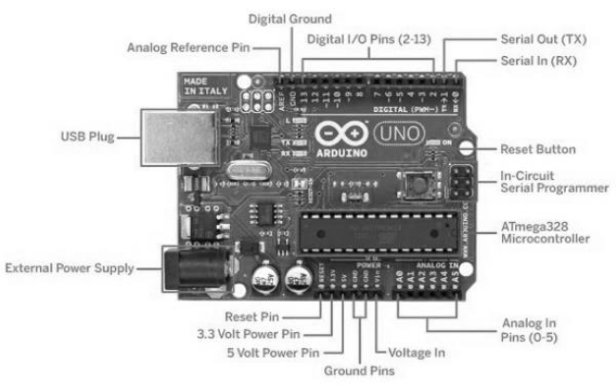
AURDINO UNO BOARD

2. Temperature and Humidity Sensor (DHT)

Temperature / Humidity sensor (DHT) shown in fig.1, measures the values of (T) and (H) periodically based on the update period with adjusted digital signal output. The sensor is considered reliable and stable due to the exclusive digital signal and data realization based Temperature / Humidity sensing module. DHT sensor is constructed of resistive type element that reads Humidity and negative temperature coefficient NTC element that reads temperature. The sensor deals with 8 – bit microcontroller which demonstrate reliability, sensitivity, stability, high response, no interference, and finally can be found in a low cost . The employed Temperature / Humidity sensor (DHT) is given by 3 pins identified as VCC connected to the 5V of Arduino, GND connected to Arduino GND, and DATA pin connected to the digital pin of Arduino board.
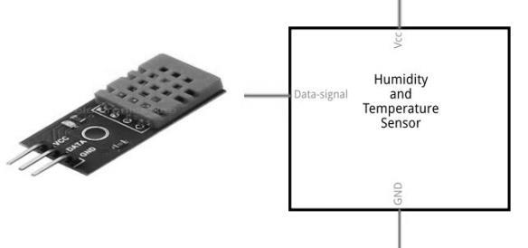
DHT SENSOR MODULE

3. LCD 16 × 2 display module

The proposed liquid crystal LCD display is considered the spotlight of this work that regularly demonstrates several data synchronously over 16 columns and 2 rows. The main function of the proposed LCD display is to show the information reported by the employed sensors as several attributes in order to clarify the situation of the system periodically. The connection scheme is proposed to be interfacing with Arduino board according to the diagram shown in Fig.3, which is prepared by Fritzing program.

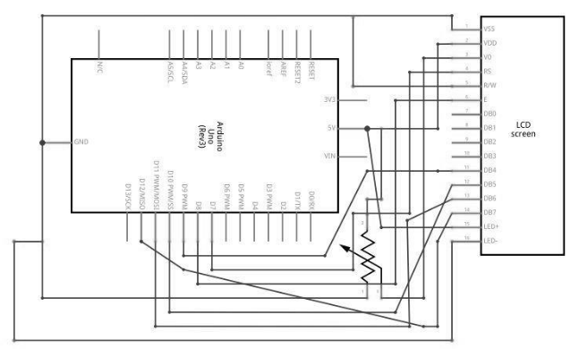

Liquid crystal LCD display allows 16 pins [5] to be connected alongside with Arduino microcontroller as exposed in following table.

PIN NO. | FUNCTION | NAME
1 | Ground 0 V | VSS
2 | Supply Voltage 5V | VDD
3 | Contrast Adjustment | VO
4 | Register Select | RS
5 | Read/write signal | R/W
6 | Data read/write enable system | E
7  8  9  10 | Low order data bus used for data transfer between microcontroller and LCD display. | D0-D3
11  12  13  14 | High order data bus used for data transfer between microcontroller and LCD display. | D4-D7
15 | Backlight 5V | LED+
16 | Backlight 0V | LED-

In accordance with the diagram exposed in Fig, the pins of liquid crystal 16 × 2 LCD display are attached to Arduino UNO as follows:

- Vss pin of the LCD is connected to the GND.
- VDD pin is connected to the 5V.
- Vo is connected to a 10KΩ potentiometer to adjust the contrast of the display.
- Rs pin is connected to digital pin 7.
- R/W pin is connected to the GND.
- E pin is connected to pin 8.
- D0 – D3 are not connected.
- D4 is connected to pin 9, D5 to pin 10, D6 to pin 11, D7 to pin 12 of Arduino respectively

IV. PROPOSED SYSTEM SCENARIO

The main governor of the system denoted by Arduino UNO controls each component separately. As mentioned before, the system is consisted of an LCD display that demonstrates the data provided by the sensors directly. DHT11 sensor that measures (T) and (H) locally based on Arduino code. The whole connection scheme of the system is exposed in below Fig, which resembles the entire components to create the proposed system. Each element in the system needed to be provided with 5V and GND from Arduino board. Accordingly, data pin of DHT sensor is attached to pin 5 of Arduino, LCD display connection is shown above. The proposed system follows a specific working scenario. The scenario is proposed to statisfy controls specifications prepared by system designer. Controller specifications have given the periority to the sensors, principally the sensors responsible for realizing weather station attributes. Firstly, DHT sensor starts measuring the temperature (T) in degree celsius (oC), humidity (H) in percentage (%) and transfers the data directly and indirectly to the display and I/O mointor of the microcontroller respectively. Finally, the main challenge of the paper is satisfied by establishing a link between Arduino serial monitor and data acquisition program based on Arduino code in order to store the proposed sensors outputs in a simple excel file to create our own database system based R-language, for any local specific area .

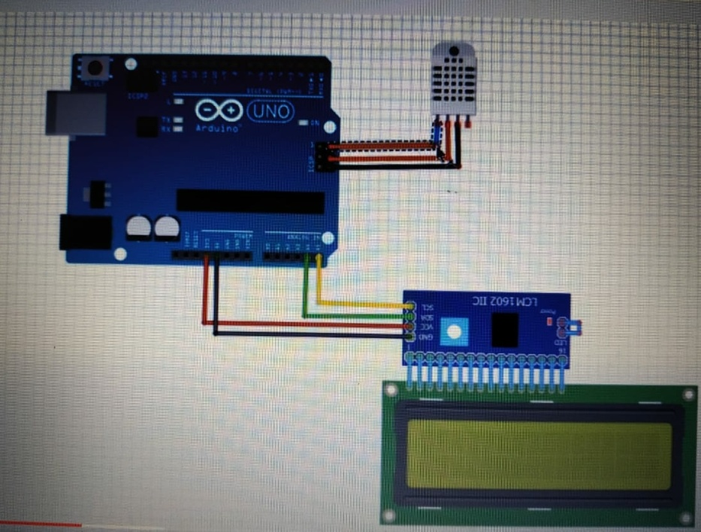

VI. SIMULATION RESULTS BASED R-LANGUAGE

FUTURE WORKS

As a future work proposal, it is proposed to apply this whole data upload on cloud and analysis the data. In addition, it has been thought to transfer and demonstrate the realized sensors data wirelessly based on Bluetooth module or Wi-Fi chip over APK smart phone application. Finally, sensors data can be sent to specific phone numbers via GSM module.

ABOUT AUTHORS



AKSHAY MALAVIYA
STUDENT
INFORMATION TECHNOLOGY
CSPIT
CHANGA,ANAND
GUJARAT,INDIA.
19it061@charusat.edu.in



KEVAL MANDANKA
STUDENT
INFORMATION TECHNOLOGY
CSPIT
CHANGA,ANAND
GUJARAT,INDIA.
19it063@charusat.edu.in

